Regulations:
A14

H.T No

Sreenidhi Institute of Science and Technology
(An Autonomous Institution)
Code No: 4A201 Date: 03-Feb-2020 (FN)

B.Tech I-Year II-Semester External Examination, Jan/Feb-2020 (Supplementary)
CIRCUITS AND NETWORKS – I (EEE)

Time: 3 Hours Max.Marks:70

Note: a) No additional answer sheets will be provided.
b) All sub-parts of a question must be answered at one place only, otherwise it will not be valued.
c) Missing data can be assumed suitably.

Part - A Max.Marks:20

Answer all QUESTIONS.

1. | What are the important features of inductance? | [2M]
2. | What is a non-planar graph? Give an example. | [2M]
3. | What are statically and dynamically induced emfs? | [2M]
4. | Derive the expression for average value of a sinusoidal alternating quantity. | [2M]
5. | Draw current locus diagram for series circuit with variable capacitance and constant resistance. | [2M]
6. | State Compensation theorem. | [2M]
7. | State and explain Kirchhoff’s current law. | [2M]
8. | State the dot convention for coupled circuits. | [2M]
9. | What are the conditions to be met for the application of reciprocity theorem? | [2M]
10. | Draw the phasor diagrams for series RL circuit and series RC circuit. | [2M]
Part – B Max.Marks:50
ANSWER ANY FIVE QUESTIONS. EACH QUESTION CARRIES 10 MARKS.

11. | a) | Explain about ideal and practical sources with suitable diagrams and characteristics? | [5M]
 | b) | Obtain the voltage drop across A-B terminals in the following circuit using Kirchhoff’s laws.  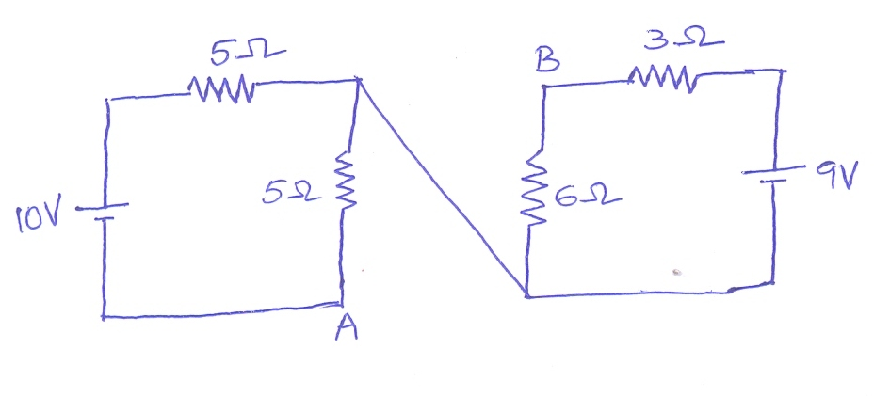 | [5M]
12. | a) | Explain the procedure for obtaining the fundamental cut-set matrix of a given network. | [5M]
 | b) | Explain the procedure adopted for drawing the dual of a given network. | [5M]
13. | a) | Find the equivalent inductance of two coupled coils connected in parallel. | [5M]
 | b) | A coil of 100 turns is wound uniformly over a insulator ring with a mean circumference of 2m and a uniform sectional area of 0.025 cm². If the coil is carrying a current of 2A, then Calculate mmf of the circuit, magnetic field intensity and flux density. | [5M]
14. | a) | Explain about the response of pure capacitance to sinusoidal excitation. | [5M]
 | b) | A 50Ω resistor is connected in parallel with an inductive reactance of 30Ω. A 20V signal is applied to the circuit. Find the total impedance and the line current in the circuit. | [5M]
15. | a) | Obtain the expression for the frequency at which maximum voltage across the capacitance in series resonance circuit in terms of Q-factor and resonance frequency. | [5M]
 | b) | Determine the quality factor of a coil for the series circuit consisting of R=10Ω, L=0.1H and C=10μF. | [5M]
16. | a) | State and explain Reciprocity theorem. | [5M]
 | b) | Determine the maximum power delivered to the load in the circuit shown in below figure.  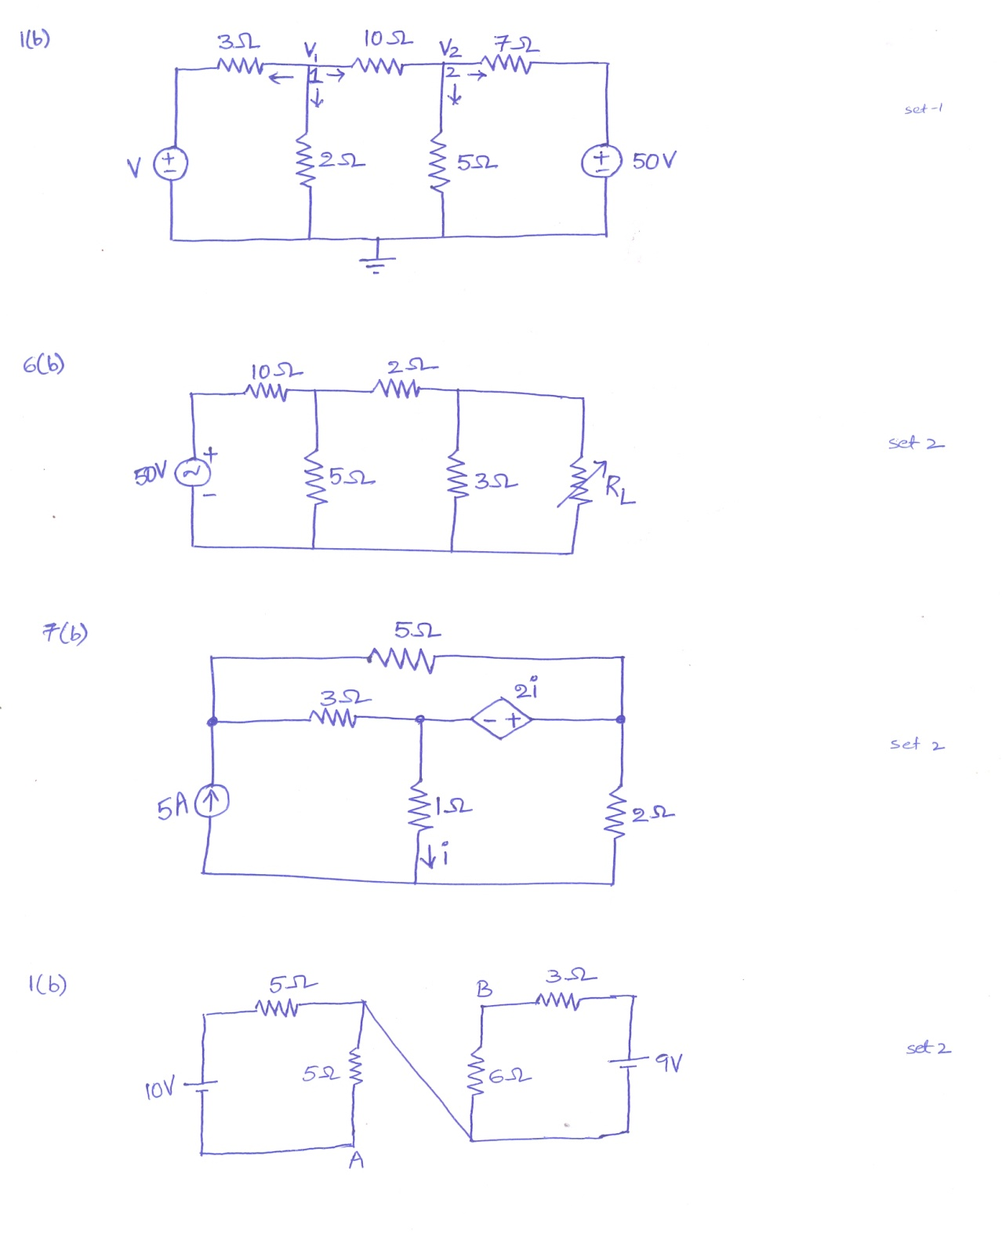 | [5M]
17. | a) | Draw the oriented network graph from the incidence matrix given below. | [5M]
  Nodes | Branches
  Nodes | 1 | 2 | 3 | 4 | 5 | 6
  A | -1 | 0 | 0 | 1 | -1 | 0
  B | 1 | -1 | 0 | 0 | 0 | -1
  C | 0 | 1 | -1 | 0 | 1 | 0
  D | 0 | 0 | 1 | -1 | 0 | 1
 | b) | Using nodal analysis, find the current through 5Ω resistor in the following circuit.  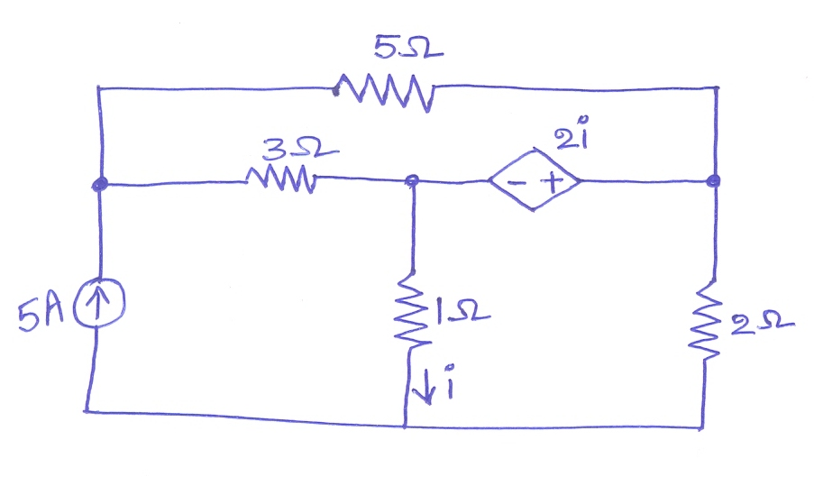 | [5M]
18. | a) | State and explain Thevenin’s theorem | [5M]
 | b) | With respect to a series resonant circuit, prove that the bandwidth is inversely proportional to Q-factor at resonance. | [5M]

-- 00 -- 00 –

